
Langford Village Academy
Summer Term Attendance Newsletter
July ‘24


Welcome to the Summer Term Langford Attendance Newsletter 2023-24
This year has been particularly challenging with illness across the school, but a huge congratulations to the 13 children with 100% attendance this year- that is a huge achievement.

As a school our aspirational target is to have over 97% attendance. Unfortunately, we are currently at 93.3% which means we are a little behind where we want to be however we are in line with national average.

How are our classes doing?

Jellyfish  90.83% | Starfish  92.65% | Seahorse  94.22% | Penguin  93.68% | Turtle  94.37%
Orca  93.39% | Dolphin  92.39% | Sea lion  94.45% | Manta ray  92.35% | Otter  93.04%
What to do if your child is unable to attend school
Frequent absence will impact on your child’s learning, both academically and socially. If your child is unable to attend school, you must phone the school office before 9.05 am every day they are unwell. You can leave a message to inform us of the absence. If we do not hear from you, we will contact you to update us on your child’s absence. If we cannot contact you, the absence will be recorded as unauthorised. Repeated unauthorised absences can lead to penalty notices.
All absences are transferred to the Local Authority so if we are concerned about your child’s attendance, you will be invited into school to discuss this further.

Punctuality
Our school gates open at 8.45 am and if your child is not in class by 9.05am, they will be recorded at late. Since the start of the year, we have had
63 different children arrive to school late, with over 84 late marks.
This accounts for a huge amount of lost learning.

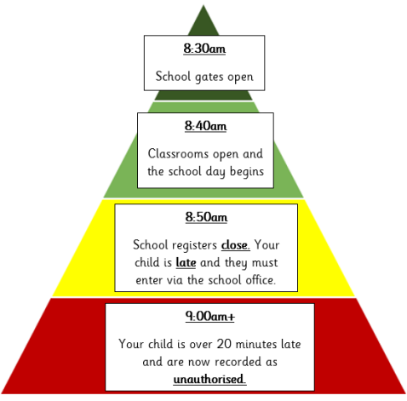
8.45am
School gates open

Does it really matter if a child is late?
Being late has a big impact on a child.
It can hinder their social development
It is detrimental to their learning, particularly if they are missing the same key session each day (Maths, Phonics and spelling)
It impacts their whole class attendance and the rewards they receive
Over time it builds up- 15 minutes late every day is the equivalent of missing 10 whole school days per year.
9.25
Your child is now late. If we do not hear from you before 9.15am, they will be recorded as unauthorised.
9.05am
The register is closed. Your child is late and they must enter via the school office.
8.55am
School gates close and the register will be taken

