School Travel Plan


Langford Village Academy
September 2025

School address: | Church Street  Langford  Bedfordshire  SG18 9QA
Existing school type (lower, middle, upper, primary, secondary etc.): | Primary
Existing number of pupils: | 293
Maximum number of pupils: | 315
Existing age range of pupils: | 5-11
Existing number of full-time staff: | 20
Existing number of part-time staff: | 32
Does the school have a catchment area or ‘nearest school’ policy? If so, where does it cover? | Village of Langford
How many of the existing pupils live within 1 mile of the school? | Approximately 70–85% of pupils live within a mile

School opening hours
School site opening and closing times: | 7.30 – 18.20
Breakfast club start time: | 7.30
School hours: | 8.55 – 15.20
Nursery or pre-school hours: | 7.30 – 18.20 (run independently)
After school club finish time: | 18.00
Regular community use outside of school hours: | After school clubs, Fayres and PTA events/parties
Description of the school site, its location, and the surrounding road network
A plan of the area should be included.
Is there more than one vehicular entrance into the school site? Where are these? Which is used the most? | One vehicle entrance off Church Street.  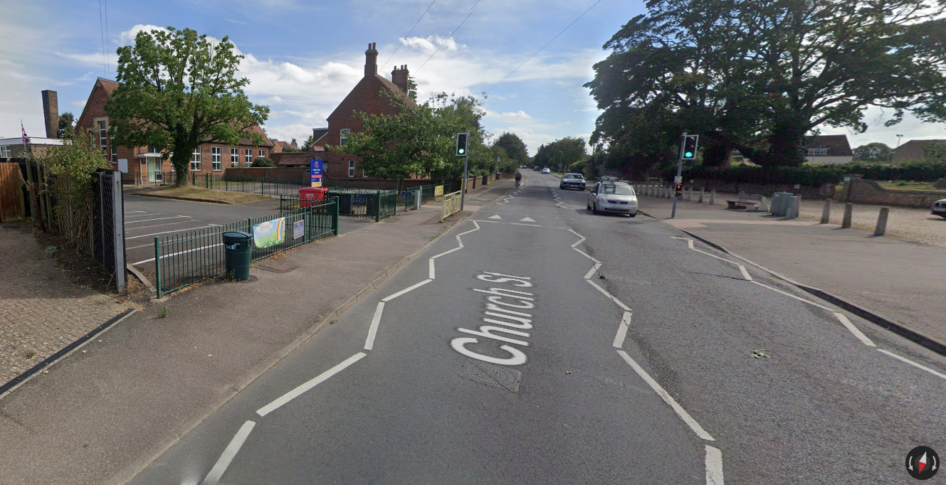
Is there more than one pedestrian and cycle entrance into the school site? Where are these? Which is used the most? | One pedestrian/ cycle entrance off Church Street.
What are the pavements surrounding the school like? Are there dropped kerbs or crossing points? | Average pavements. Dropped kerbs at new controlled crossing.
Does the main road outside of the school have any traffic calming, a school crossing patrol, or a controlled crossing such as a zebra, toucan, or pelican? | The school is located in the centre of Langford on a straight road, which gives drivers good visibility of any crossing children.  There is a controlled crossing outside the school and speed humps along Church Street which has a 20mph limit.
What is the speed limit on the roads surrounding the school? | 20mph along Church Street.
Is there a speed limit within the school grounds? | 5mph
Is there a cycle route nearby that connects into the school site? (Cycle maps) | No.
Are there any other schools nearby? | No other schools nearby.

Existing travel patterns – pupils
Data should be taken from the most recent ‘Hands Up’ travel survey (completed in September each year).
How do pupils usually travel to school for the main part of their journey?
2024 data:
Number of pupils present: | 276
Number of pupils absent: | 6
Date data collected: | 17/9/24
Walk: | 89
Cycle: | 11
Scoot / skate: | 38
Public bus: | 0
School bus: | 0
Park and stride: | 23
Train: | 0
Car share*: | 9
Car: | 106
* Car share is defined as travel in a car with someone from another household.
Compare the data above to that collected in the last couple of years. Has there been an increase or reduction in a particular mode of travel? Is there a known reason for this? How does this relate to the number of pupils that live within 1 mile of the school? Could more pupils be encouraged to travel sustainably?
2024: 38% car use
2023: 37% car use
2022: 49% car use

Existing travel patterns - staff
Data should be taken from the most recent ‘Hands Up’ travel survey (completed in September each year).
How do staff members usually travel to school for the main part of their journey?
2024 data:
Number of staff present: | 41
Number of staff absent (who would usually be expected at school on the day the data was collected):
Date data collected: | 17/9/24
Walk: | 12
Cycle: | 3
Public bus: | 0
Park and stride: | 3
Train: | 0
Car share*: | 0
Car: | 23
* Car share is defined as travel in a car with someone from another household.
Compare the data above to that collected in the past couple of years. Has there been an increase or reduction in a particular mode of travel? Is there a known reason for this? Are there any barriers to increasing the use of sustainable travel?
2024: 56% car use
2023: 57% car use
2022: 70% car use
Existing parking arrangements

Total number of existing parking spaces within the school site: | 18
Are there any disabled parking spaces? If yes, how many? | 2
Are there any electric vehicle charging points? If yes, how many? | No
Are any of the parking spaces allocated to another specific group such as visitors, parents, students, or anybody else? If yes, how many? | No.
Are any arrangements in place to allow additional parking at a location outside of the school site? If yes, where is this and how many parking spaces are permitted? Are there any restrictions on when these parking spaces can be used? Is permission in place? | We have permission from the church and village hall to park cars in the car park opposite the school. Parents, staff and visitors use these.
On an average day, do any staff have to park on the road. If yes, how many? | Yes- about 5
Are those attending the school for community use outside of usual school hours able to use the school car park? | Sometimes
Who are the car parking arrangements managed by? | Our caretaker, Paul
Are there any bus or coach parking spaces within the school site? If yes, how many? | No
Existing cycle and scooter parking facilities
Refer to Parking Standards for New Developments SPD.
Are there any existing cycle stands installed at the school? Are these covered? Where are these located? How many bikes can be parked? | Yes, at the front. 30
Are there any existing scooter parking facilities at the school? Are these covered? Where are these located? How many scooters can be parked? | Yes - shared, as above
Is the cycle and scooter parking area(s) easily accessible for those with bikes and scooters? Are there any improvements that could be made? | Yes-located at the front of the school
Does the school have any locker facilities or a safe place where cycle helmets can be stored for both pupils and staff? | No lockers. Cycle helmets can be hung on pegs.

Summary of existing sustainable travel initiatives
Are there any sustainable travel initiatives already in place? For example, is car sharing promoted? Is there a park and stride location? Have Junior Road Safety Officers been appointed? Is Bikeability and scooter training in place? Do the school take part in Walk to School Week / Month, Big Walk and Wheel, Bike Week, Santa Challenge? Is travel information provided on the school’s website? How are these initiatives communicated to pupils, parents, and staff – newsletters, website, emails, noticeboards?
The schools takes part in Bikeability training and works with CBC road safety team.
We promote sustainable travel activities on our website Langford Village Academy - School Travel Initiatives and on noticeboards.
Details of the school travel plan are included in packs for new parents.
The school takes part in Bikeability training.
The village hall is used for extra parent/ staff parking, though spaces are limited.
1st Solo Journeys using VR sets to years 5 & 6 and also the Green Cross Code to early years pupils.

Summary of travel practices at the start and end of the school day
In relation to travel at the start and end of the school day, what currently works well? For example, a high proportion of pupils walk, scoot or cycle, good parking etiquette by those collecting pupils, good compliance with waiting restrictions, a School Crossing Patrol, a controlled crossing that is well used etc.
Controlled crossing well used. Lots scoot and cycle. Parents are usually respectful of others.

In relation to travel at the start and end of the school day, what could be improved? For example, parking that causes congestion, parking on pavements, poor compliance with waiting restrictions, parked vehicles restricting visibility at junctions, narrow pavements, no dropped kerbs at junctions etc. How are parents contacted when issues occur – newsletters, website, email?
Parents are advised not to park close to the school through parent mail, newsletters and via the website.

Targets
Include annual targets (for example reduce car use by 2%, increase walking, cycling or scooting by 2%).
We will aim to reduce car use by 2%.
Aim of the School Travel Plan
Some ideas are as follows:
- To understand the existing travel patterns for journeys to and from school.
- To increase the number of journeys to and from school using a sustainable mode of travel.
We have very strong links with the local community. Parents, pupils, villagers, teachers and staff share the concerns regarding journeys to, from and during school. This Travel Plan will demonstrate our continued commitment from our whole community, not just our school, to improve the local environment and increase safety.
- To continue to identify and alleviate the main obstacles to a safe walking journey to school
- Continue to reinforce travel safety awareness within the curriculum
- To increase the numbers of children travelling sustainably to school
- This travel plan will be part of our healthy school programme and used to tie in with our environment awareness
Objectives of the School Travel Plan
The objectives identified should address the travel improvements identified. Some ideas are as follows (there should be a minimum of 5 objectives):
- To reduce the number of cars parked on surrounding roads at the start and end of the school day.
- To increase the number of pupils walking, cycling and scooting to school.
- To promote the existing bus routes.
- To promote park and stride.
- To encourage car sharing.
- To establish a working group.
- To reduce traffic and parent parking
- To continue to reinforce road safety training for pupils and staff
- To actively promote good citizenship amongst pupils
- To increase the numbers of children travelling sustainably to school
- To promote park and stride
- To encourage car sharing
- To establish a working group
How will the objectives be achieved?
Some ideas include:
- Consider whether additional waiting restrictions may be required.
- Prepare a travel information leaflet or webpage on the school’s website that is shared with pupils, parents, and staff. Add this to noticeboards.
- Include bus routes and timetables in the published travel information (refer to Traveline).
- Set up a park and stride scheme - investigate whether there is a local car park that could be used by parents at the start and end of the school day (permission will need to be agreed).
- Encourage staff to lift share (either organise between themselves or via Liftshare).
- Set up a system to encourage parents to car share.
- Encourage staff to take advantage of Cyclescheme.
- Set up a School Travel Plan working group (to include school staff, parents, governors, and representatives from the community).
- Staff and pupils have high visibility tabards for use when crossing the roads
- Letters are sent to parents to remind them not to park in the car park or close to the school. There are notices on the school railings. This information is also on the school website
- Encourage staff to Liftshare
- Encourage staff to take advantage of Cyclescheme
- Set up a School Travel Plan working group (to include school staff, parents, governors, and representatives from the community)
- Bus routes are not conducive with pupil hours but may suit some staff. Service 74 (Hitchin, Biggleswade, Bedford) runs as follows:
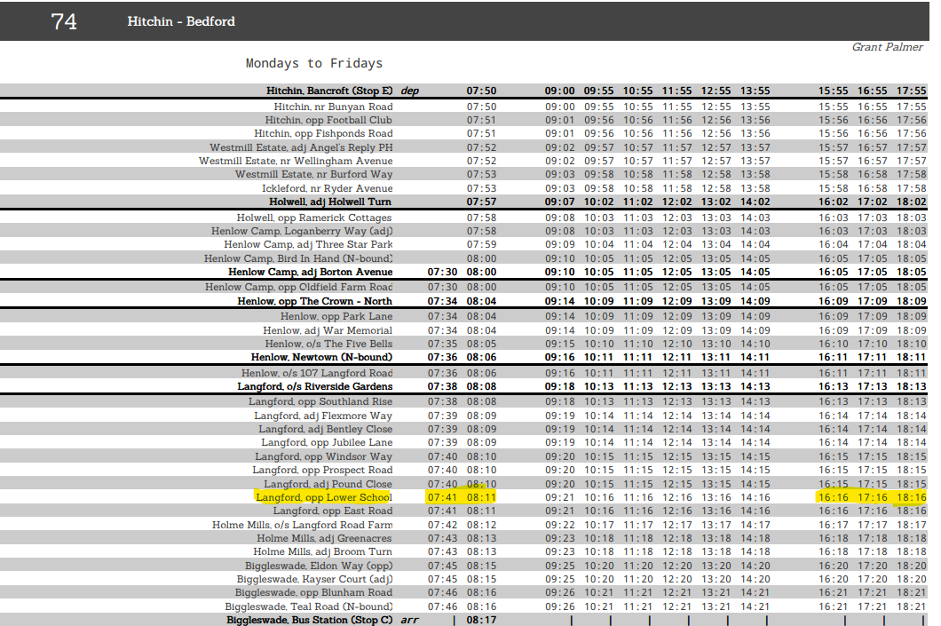

Action plan
Each school is required to complete an action plan which will include short, medium, and long-term initiatives that are intended to be completed or worked towards, to achieve the aims and objectives of the School Travel Plan. The action plan should be reviewed and updated annually and sent to the CBC Travel Plan Officer.
Proposed action | Description of the action | Action to be completed by (name) | Proposed completion date
Travel Plan Co-ordinator | Appoint a Travel Plan Coordinator. Include contact details. | Gary Gotham | September 2025
School Travel Survey | Complete ‘Hands Up’ school travel survey and send to CBC. | TPC | September each year
Marketing / publicity | Update the School Travel Information webpage. Make available to parents via website/ newsletters/ emails/ noticeboards. | TPC | December 2025
Working Group | Set up a Travel Plan working group (to include school staff, parents, governors and representatives of the local community). To meet termly. | TPC | December 2025
Modeshift STARS | Sign up to Modeshift STARS. Fill in details of any sustainable travel initiatives that have already been completed (refer to Modeshift STARS Education Initiatives). | TPC & CBC | Signed up – updates to be made by October 2025
Modeshift STARS | List Modeshift STARS initiative number 1 (Modeshift STARS Education Initiatives).  Bikeability | TPC | Annually (last booked July25)
Modeshift STARS | List Modeshift STARS initiative number 2.  Santa Challenge | TPC | December 2025
Modeshift STARS | List Modeshift STARS initiative number 3.  Big Walk and Wheel | TPC | April 2026
Modeshift STARS | List Modeshift STARS initiative number 4.  Walk to School Week | TPC | May 2026
Modeshift STARS | List Modeshift STARS initiative number 5.  Road safety initiatives - 1st Solo Journeys using VR sets to years 5 & 6. Green Cross Code to early years pupils. JRSOs to be considered. | TPC | June 2025 and annually
School Travel Plan Review | Agree the date for an annual School Travel Plan review with key stakeholders | TPC | Annually
School Travel Plan approval
School Travel Plan Co-ordinator: | Signature: | Gary Gotham
School Travel Plan Co-ordinator: | Print name: | Gary Gotham
School Travel Plan Co-ordinator: | Job title: | Assistant Principal
School Travel Plan Co-ordinator: | Email: | ggotham@bestacademies.org.uk
School Travel Plan Co-ordinator: | Telephone: | 01462 629000
School Travel Plan Co-ordinator: | Date: | 10.09.25

School Head Teacher: | Signature: | Debbie Randall
School Head Teacher: | Print name: | Debbie Randall
School Head Teacher: | Job title: | Principal
School Head Teacher: | Email: | drandall@bestacademies.org.uk
School Head Teacher: | Telephone: | 01462 629000
School Head Teacher: | Date: | 10.09.25

Chair of Governors: | Signature: | Anne Gilbert
Chair of Governors: | Print name: | Anne Gilbert
Chair of Governors: | Email: | agilbert@bestacademies.org.uk
Chair of Governors: | Telephone: | 01462 629000
Chair of Governors: | Date: | 10.09.25

School Travel Plan notes
- We ask that every school has an active School Travel Plan which is updated and submitted annually, but it can be amended or added to throughout the year as measures are implemented.
- This template has been put together to assist each school in putting together their School Travel Plan. This template doesn’t have to be used; it is recommended that if a different format is adopted that the content is cross referenced with this template to ensure that everything is included.
- To accompany the School Travel Plan, we ask that a travel information leaflet or webpage on the school’s website is prepared to include relevant walking and cycling maps, public transport details, and car-sharing information. The travel information leaflet or webpage should be communicated to parents, pupils, and staff.
- The school should appoint a named Travel Plan Co-ordinator who will be responsible for the overall management of the School Travel Plan and be a main point of contact at the school for any travel and transport related enquiries.
- A working group involving the school, parents, governors, and representatives of the local community should be established. The group should meet regularly to discuss any issues and implement changes in encouraging sustainable travel.
- Once completed an electronic copy of the School Travel Plan and travel Information leaflet or webpage should be sent to travel.choices@centralbedfordshire.gov.uk.
Sustainable travel initiatives
More information about the initiatives below and other sustainable travel suggestions can be found in Central Bedfordshire Council’s Sustainable Modes of Travel to Schools and Colleges Strategy.
- Modeshift STARS
- Bikeability
- Junior Road Safety Officer
- Lift Share

