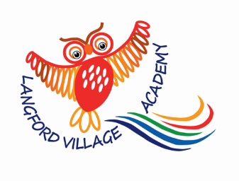
Langford Village Academy

Our Intent, Implementation and Impact for Foundation Stage

Intent
In the EYFS at Langford Village Academy our curriculum is designed to provide first hand learning experiences whilst allowing the children to become confident, happy, independent learners. We teach through topics, but follow the children’s interests to set out play activities that will engage and develop their interests. The ability to learn is underpinned by the teaching of basic skills, knowledge and concepts. We work closely with parents to develop a good home/ school relationship which supports learning and communication for all of our children. We also work closely with any outside agencies that are supporting the children. We use Tapestry to share photographs with parents and have weekly emails to keep parents up-to-date with our weekly topics.

Implementation
At Langford Village Academy we follow the Early Years Statutory Framework for the Early Years Foundation Stage from the DfE. This framework specifies the requirements for learning and development in the Early Years and provides prime and specific areas of learning we must cover in our curriculum. We use Development Matters to get our steps of progression.

We have a curriculum that is child centred and based upon wow experiences and half termly topics that engage children. We encourage active learning inside and outside. We take time in the first couple of weeks to build strong relationships with each child and get to know their interests and likes to support their learning.

We involve the children’s families in our learning journey with shared experiences. Families are invited to our Harvest Festival at the school and Easter celebrations at the church. We have two Grandparent’s sessions where Grandparents visit in the first half term for their grandchildren to show them around their classroom and have the opportunity to do themed activities together. There is a Christmas Crafts Day where a family member can come in and support children making lots of varied Christmas crafts.

All areas of the EYFS curriculum are followed and planned for to ensure there is a broad, balanced and progressive learning environment and curriculum. The children have opportunities for child-centred play through out the day and we will add to the play activities to support deeper understanding and progression through careful observation and interaction with the children. We celebrate our topic learning with a wow day bringing together lots of our learning and exciting, fun investigations and crafts.

The children will have a daily taught phonics and maths session, which is followed by a small group activity with an adult twice a week. The children will have at least two sessions of one to one reading with an adult. There is a daily taught topic session four times a week and follow up activities in small groups.

We value the children’s oracy skills and plan a ‘Fantastic Foundations’ session once a week to play a word and a sentence building game to develop children’s language and communication skills.

Impact
The impact of our curriculum is measured by formative assessments in our lessons and through observing and engaging in the children’s play. These assessments are used to inform our planning for class activities and for any booster groups that may be needed to ensure the children build upon their current knowledge and skills at a good pace.

Summative assessment compares children’s attainment to age related expectations using age bands from Development Matters and the Early Learning Goals. This is tracked using Insight to ensure rates of progression are at least good for all children, including vulnerable groups such as those with SEND, disadvantaged or summer born children. Our assessment judgements are moderated in school, with Gravenhurst Village Academy and other BEST Early Years Classes.

The impact of our curriculum will also be measured by how effective if develops our early years children to be well rounded, confident learners who show the values of the school and a love of learning, ready for the challenges of KS1.

